Object Oriented Programing lab
Project Report
E-Voting system



Submitted by:
Nauman Ahmad 2024-CS-740
Abshar Husain 2024-CS-742
Abdul-Nafay 2024-CS-722

Submitted to:
Ms. Zoha

Dated:11 May 2025

Department of Computer Science
University of Engineering and Technology Lahore, New Campus

Table of Contents
1. Introduction: 3
2. Objectives: 3
3. Methodology: 3
4. Working of console code: 3
5. Result and Analysis: 3
6. Git Hub Link 3
7. UML Diagram: 3
7. GUI: 4
8. Technology used in GUI: 5
7. Schema of GUI: 6

1. Introduction:
This is an E-Voting system, here people can cast vote in different areas and different levels for multiple candidates.

2. Objectives:
- It makes it easier for voters to cast vote.
- It is time and cost effective.
- The results will be pure without any third-party interference.

3. Technologies Used:

- GUI QT Designer
- Data-base SQLite
- Language C++
- Architecture MVC+ Singleton pattern
- Chart Library QT charts

4. Working of console code:

So we have total 8 classes. Their UML diagram and relation with reach other is given in UML section.
In implementation, we have 2 main users. One is admin and the other is Voter.
- Admin:
Admin can add voter, add candidate, view voter, view candidate, add election, view elections, view results.
- Voter:
Voter can view available elections, cast elections, view vote status
- Election Class:
The election class is made to make elections. Local level or National Level.It is inherited in Admin section so by using this class admin can create elections.
- User Class:
It is abstract class that is only for the purpose that it can share attributes of it self.We can’t make objects of this class.

We have another user which is candidate but it is totally managed by admin, For example, it can created by admin, different elections are assigned to candidate and who is winning, it is also managed by admin.

5. Result and Analysis:

The results are valid. When the voters cast votes, the are incremented in a counter in the object of candidate, After all voted, The candidate in a election (whom results are been shown) whose counter value is higher will be the LEADER.

6. Git Hub Link

https://github.com/Abshar-980/full-stack-OOP.git

7. UML Diagram:
The class UML Diagram is Given Below.
T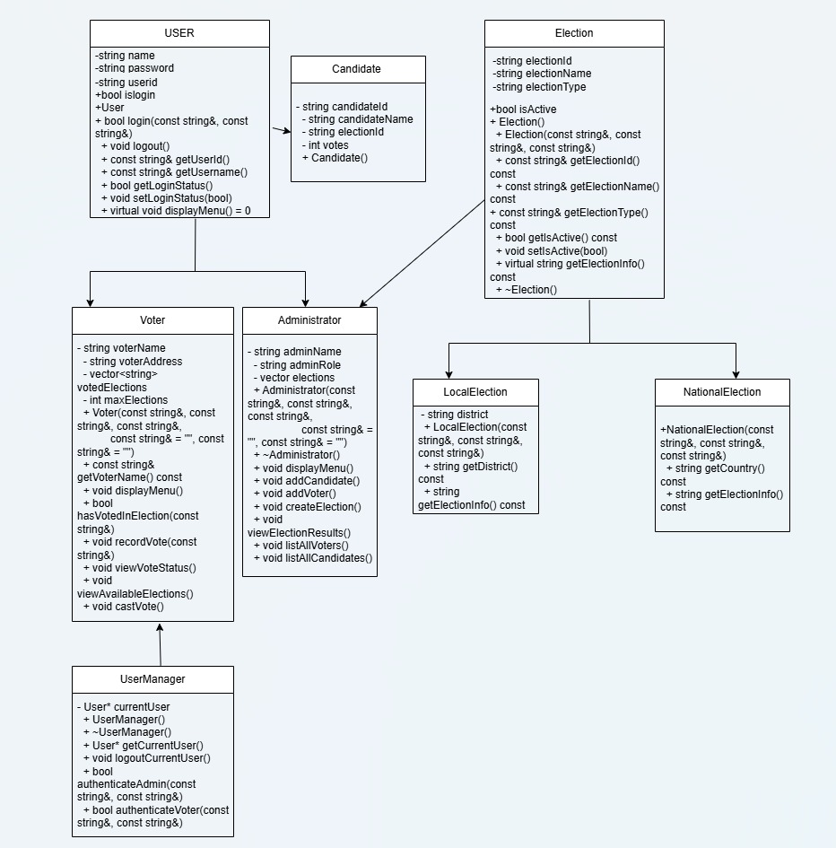

7. GUI:

GUI is our addition project and our plus point. We use QT software for GUI. In interface, all the working is same, but it is user friendly. In it we use Database instead of file handling. It is more reliable and easy for user. We use graphics for results. Some of the screenshots are as follow:

1. Login Page:
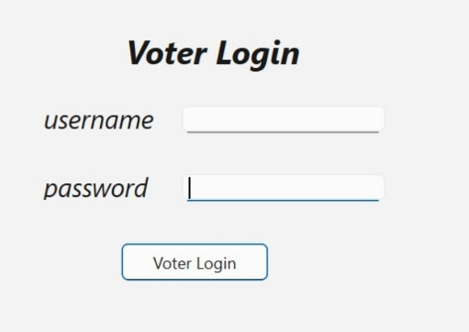
2.Results:
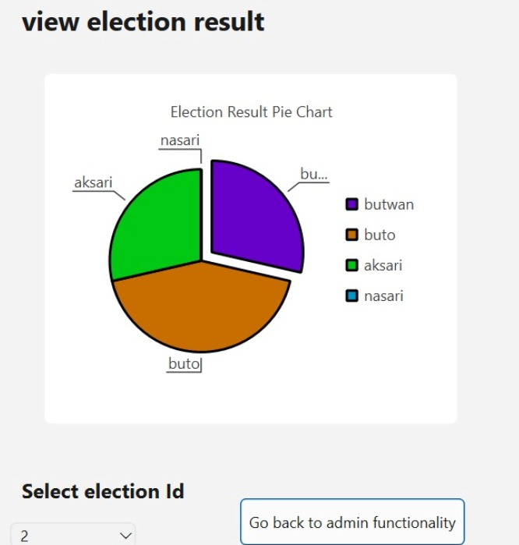

3.Views
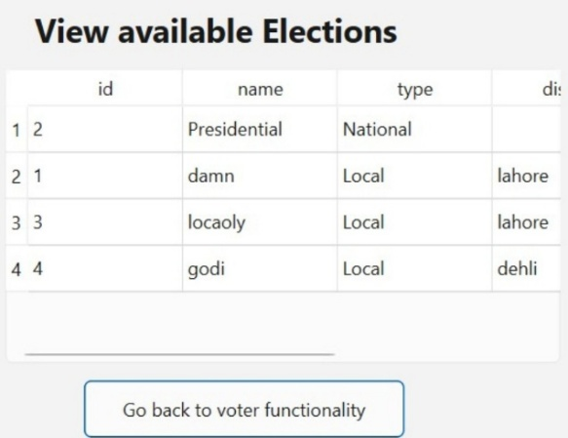

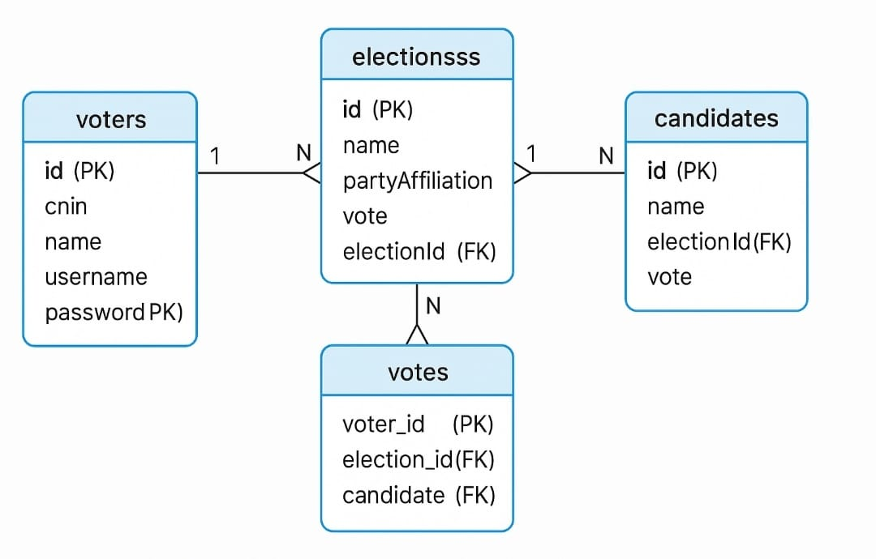
Data-Base schema Used in Project:

